**AWS CSA: Task-1**

**Task Description - AWS 👨🏻‍💻**

**🔅 Create a key pair**

**🔅 Create a security group**

**🔅 Launch an instance using the above created key pair and security group.**

**🔅 Create an EBS volume of 1 GB.**

**🔅 The final step is to attach the above created EBS volume to the instance you created in the previous steps.**

**All the above steps must be performed using AWS CLI**

**===============================================**

* Create a key pair🔅 Create a key pair

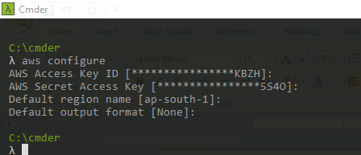

Open PowerShell:

C:\Users\Being_Pawan\Desktop\aws_csa_tasks> **aws ec2 create-key-pair --key-name MyKeyPair --query 'KeyMaterial' --output text | out-file -encoding ascii -filepath MyKeyPair.pem**



* Create a security group

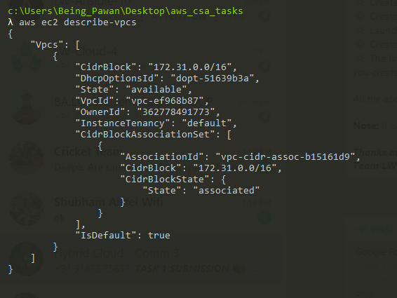

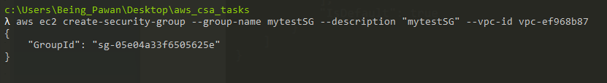



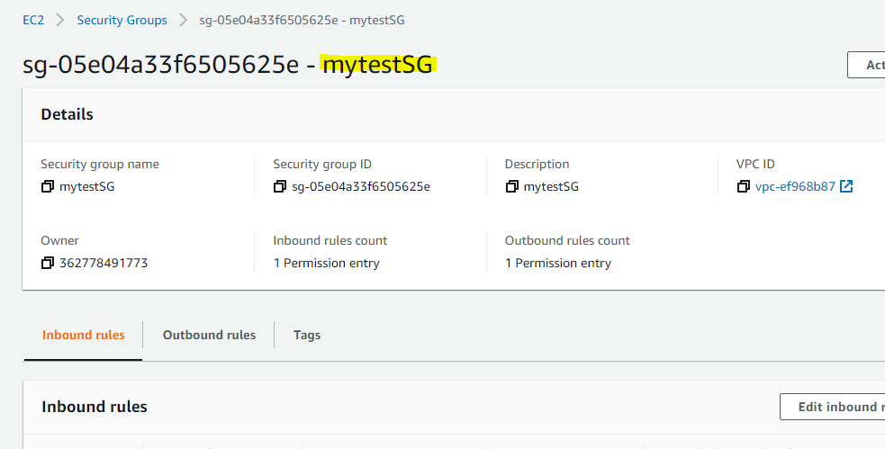

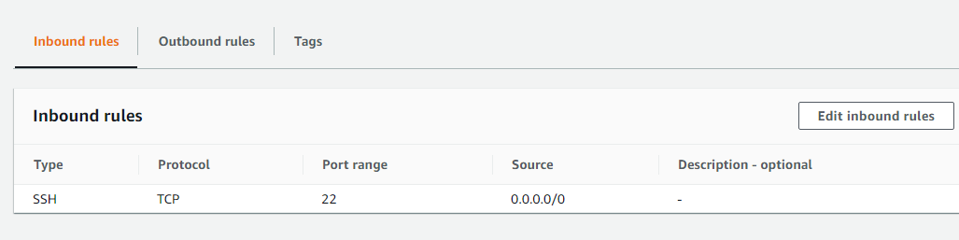

* Launch an instance using the above created key pair and security group.

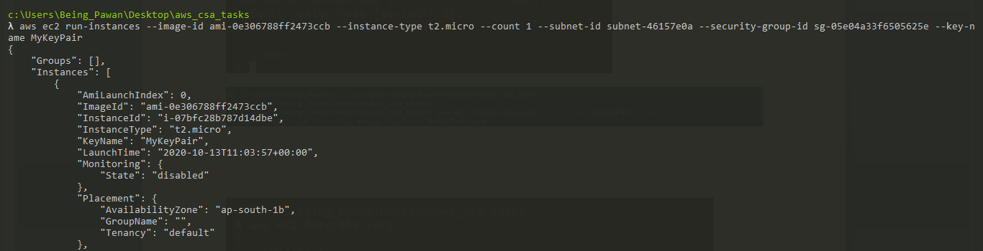

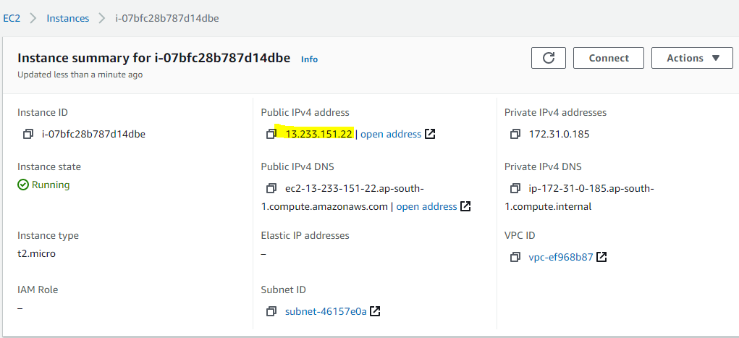

* Create an EBS volume of 1 GB.

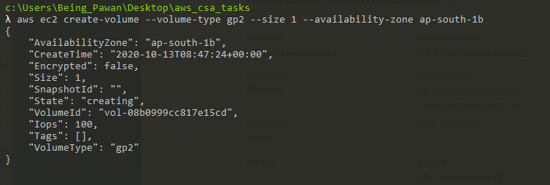

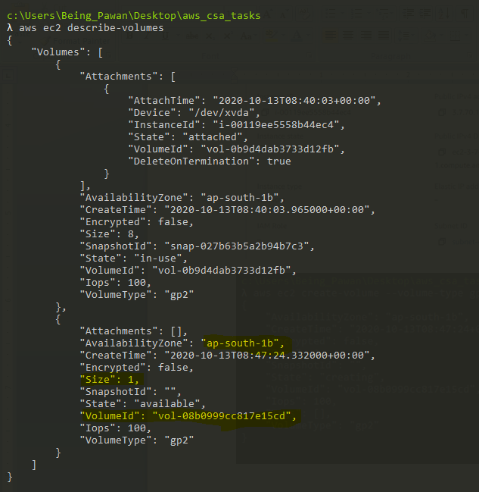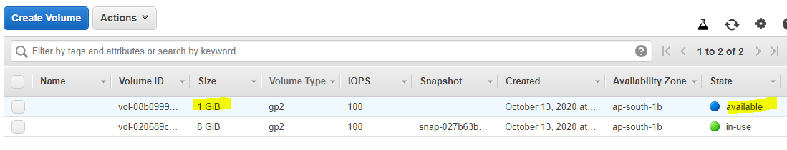

The final step is to attach the above created EBS volume to the instance you created in the previous steps.

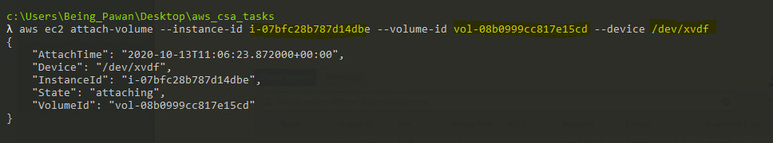

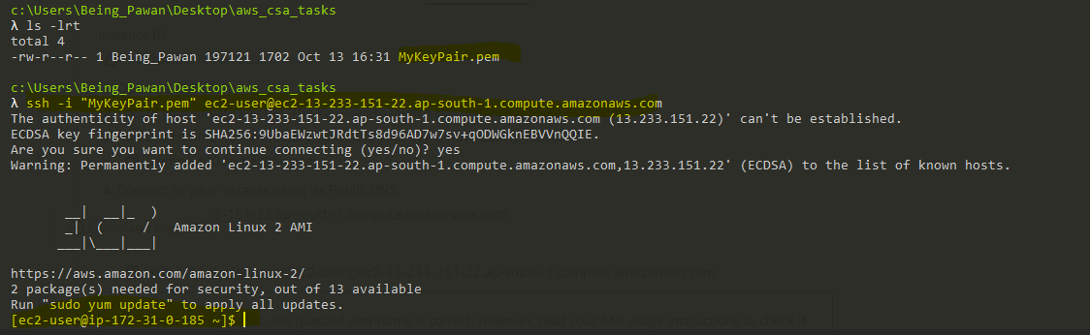

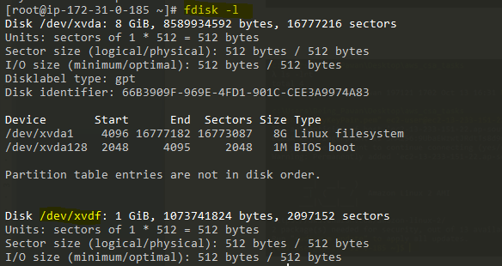

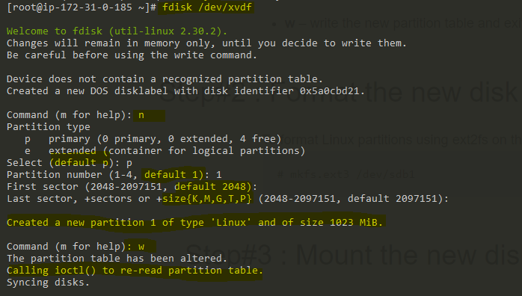

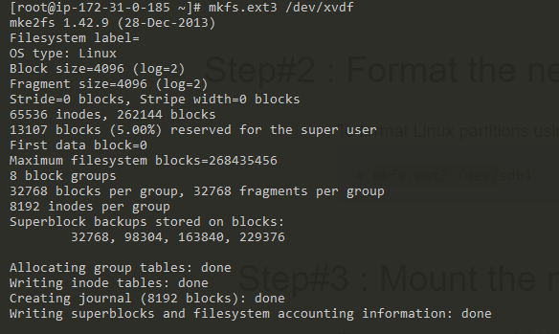

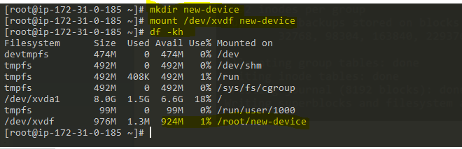

Mounted successfully!!!